**Project Documentation**

**Project Title:** Shipping Details

**Technologies Used-**HTML, CSS, JS, REACT.

**Project Description:**

This project is a form type react project made for the taking the entries of shipping details and storing and displaying in a tabular form.

**How to Install and Run the Project:**

This is a React application and hence needs to be forked and cloned in your system and then Run it with the code **npm start** in the console with pre- requisite of nodejs installed in your system and the directory should be the one in which **package.json** file is present.

**Screenshots:**

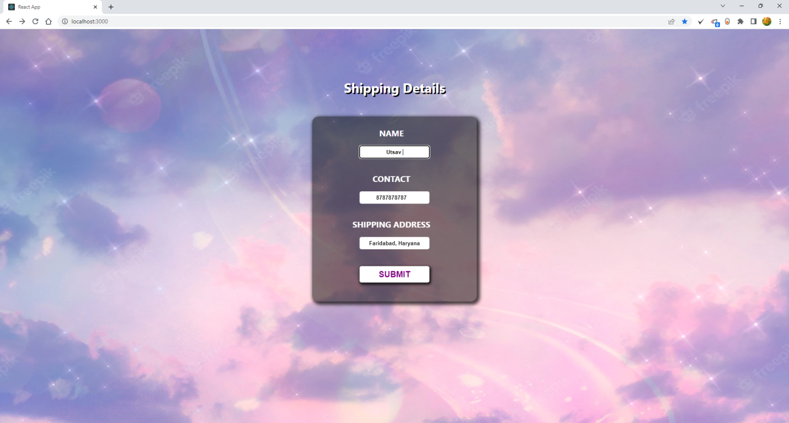

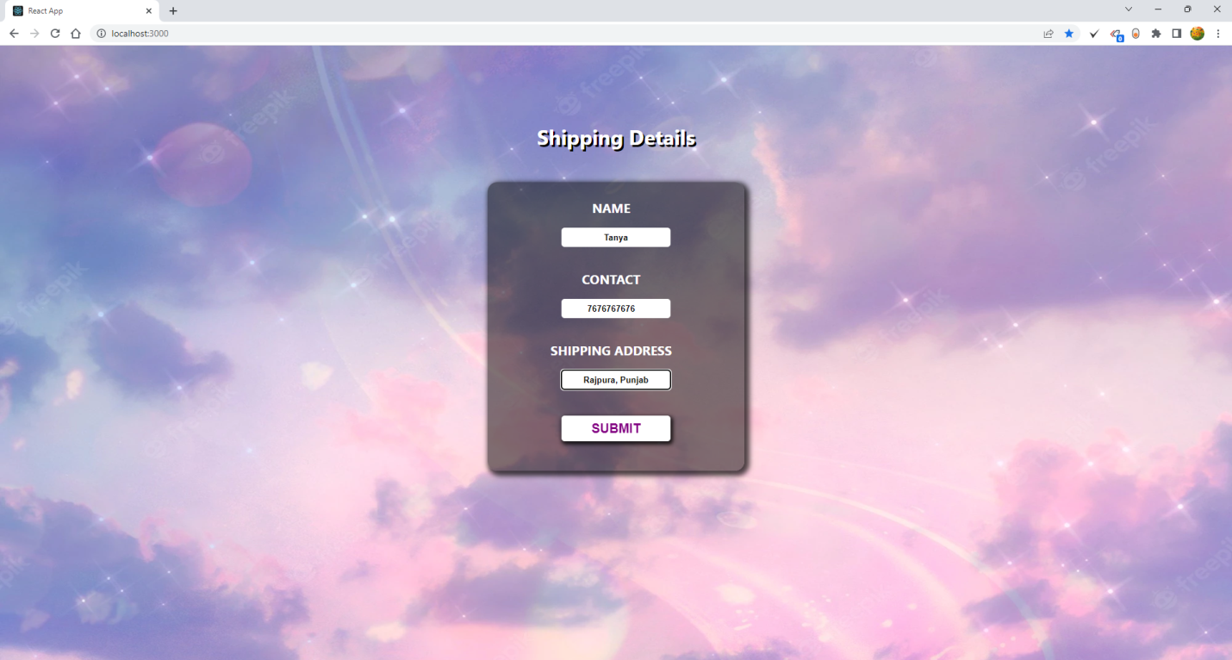

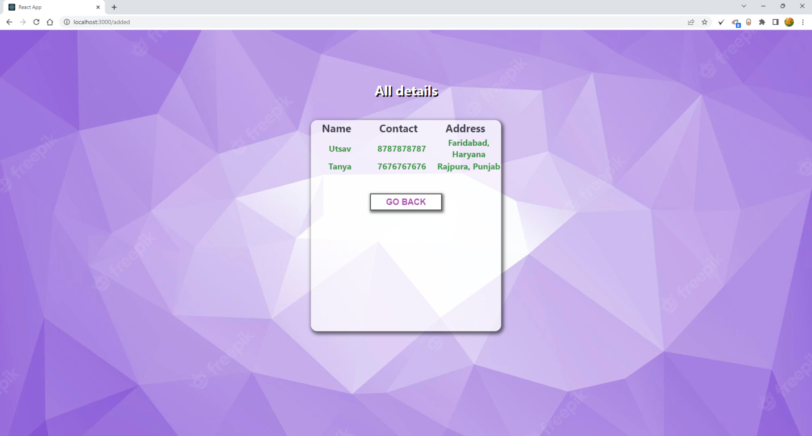

**Conclusion & Scope of Improvement:**

This react app is just a part of a shopping website which only serves the purpose of taking the shipping details. Soon it will be combined and its purpose will be fulfilled.